CLASS DIAGRAMS: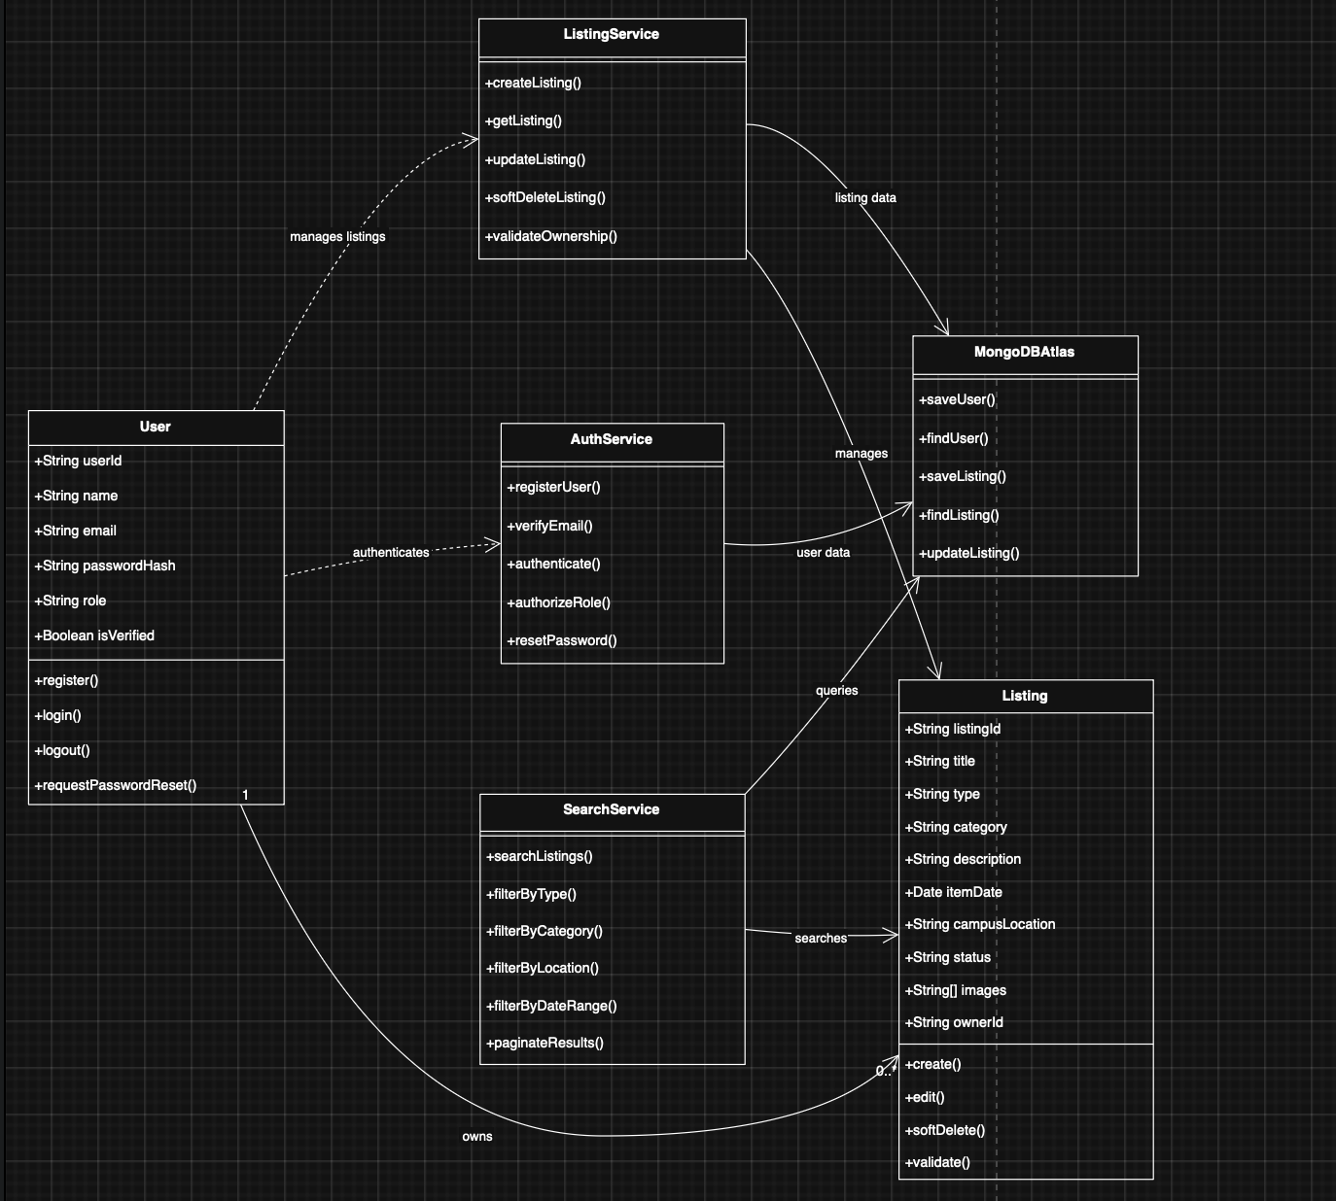
Class diagram for phase 1

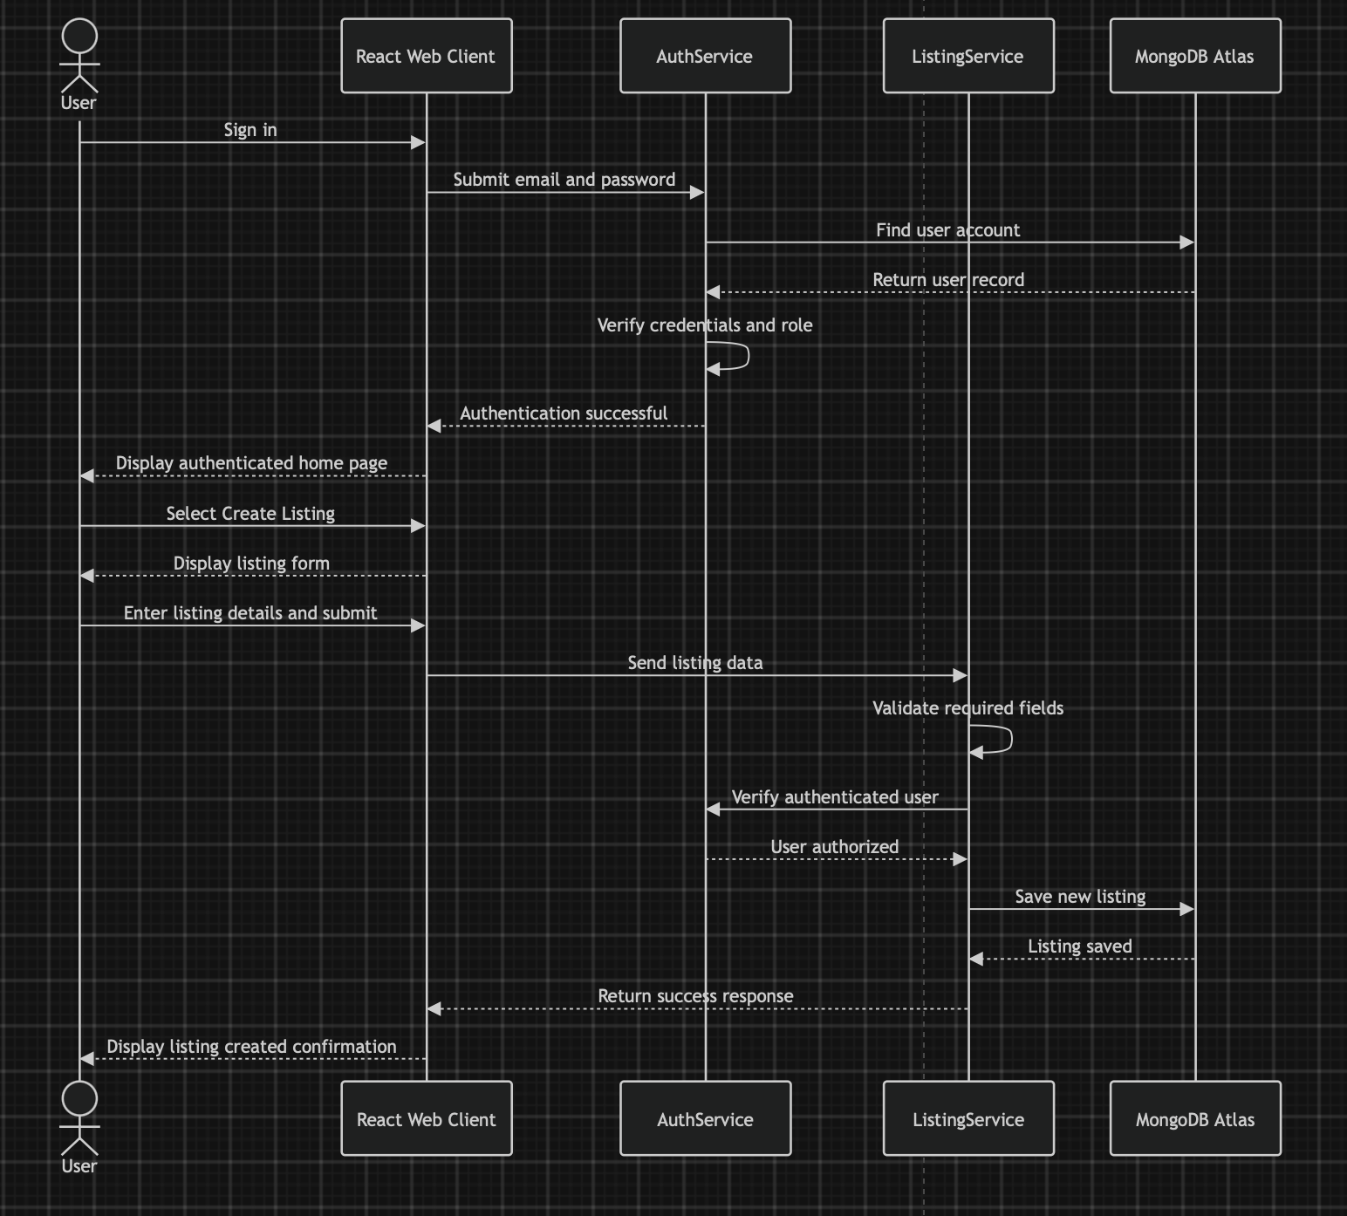Sequence diagram for phase 1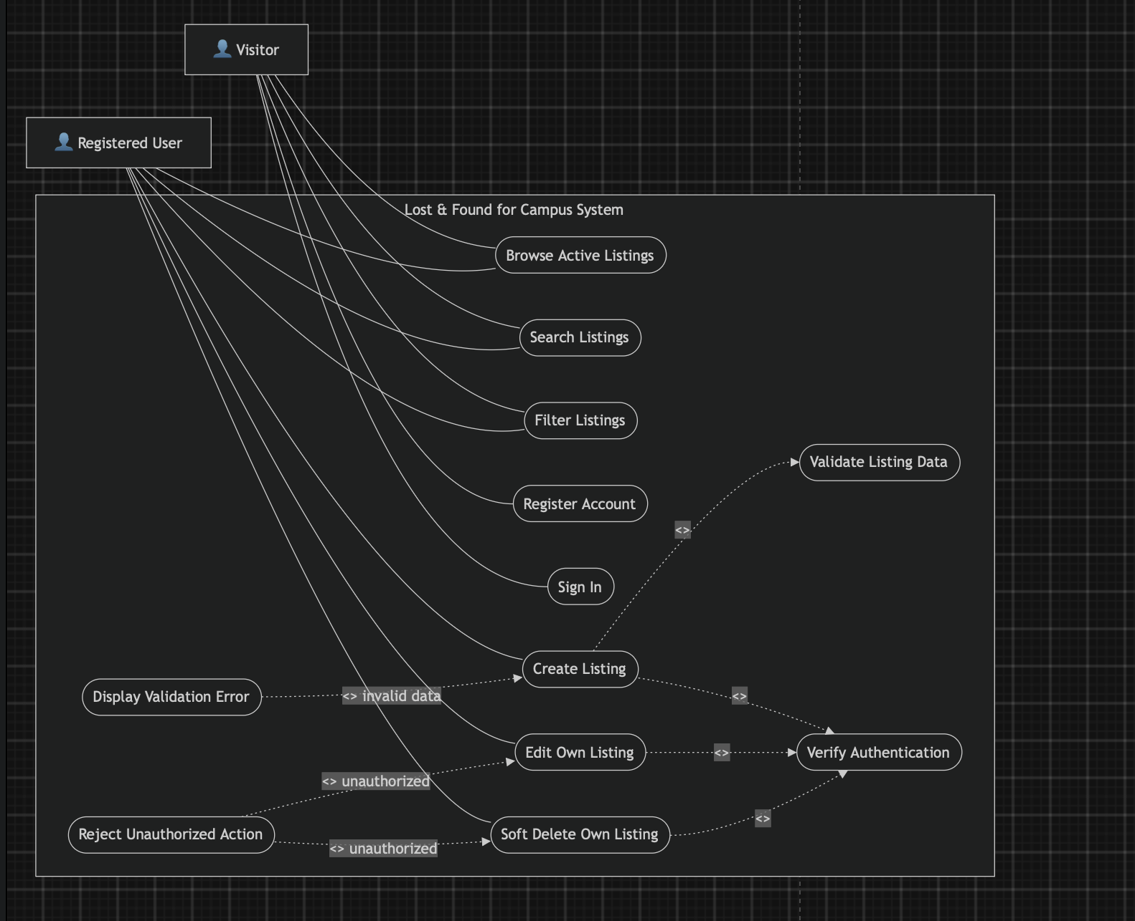
The Use Case Diagram shows how Visitors and Registered Users interact with the Lost & Found system.
In the valid flow, an authenticated user provides valid listing details, allowing the system to create or update the listing successfully.
In the invalid-data flow, missing or incorrect listing information triggers a validation error instead of completing the action.
In the unauthorized flow, the system rejects attempts to edit or delete another user’s listing, protecting listing ownership.

